Supplemental material to Retribution as hierarchy regulation: Hierarchy preferences moderate the effect of offender socioeconomic status on support for retribution

Exploratory Factor Analysis

This supplement is associated with the paper “Retribution as hierarchy regulation: Hierarchy preferences moderate the effect of offender socioeconomic status on support for retribution”. It examines the factor structure of the main outcome measure, the Retributive Justice Orientation Scale, used in the paper.

We examined the Retributive Justice Orientation Scale’s (RJOS) factor structure using an exploratory factor analysis (EFA) of the data from Study 1 (the only study where nothing was manipulated before the scale was administered). We specified an EFA using Principal Axis Factoring with (oblique) Direct Oblimin rotation. A scree plot of the Eigenvalues by factor number largely supported the RJOS’s unidimensionality according to two heuristic stopping rules for factor extraction (see Figure 1). A parallel analysis (Horn, 1965; as used in, e.g., Nichols & Webster, 2015; SPSS syntax drawn from O’Connor, 2000) marginally supported either a one- or two-factor structure. A broken-stick analysis (Jackson, 1993) more clearly supported the RJOS’s one-factor structure because the observed Eigenvalues exceeded the broken-stick estimate for Factor 1, but not Factor 2.

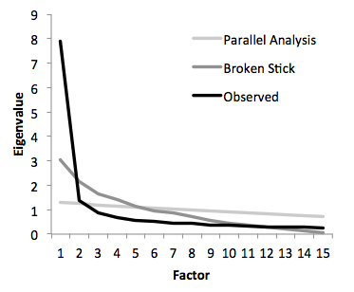

Figure 1. Retributive Justice Orientation scree plots of Eigenvalues by number of factors: observed, parallel analysis, and broken-stick analysis criterion. All fifteen items were subjected to Principal Axis Factoring.

Because one of two heuristic metrics marginally supported either a one- or two-factor structure, we conducted additional analysis to better adjudicate between one- and two-factor solutions. To do so, we followed an approach that would, firstly, correct for the artificial inflation of the number of factors that comes from large numbers of items. We also wanted to better represent our theoretical supposition that each subscale indicates latent retributivism. To achieve both goals, we treated Retributive Justice Orientation as a meta-factor, factor analyzing subscale means rather than individual items. This analysis more clearly indicated a single factor (see Figure 2).

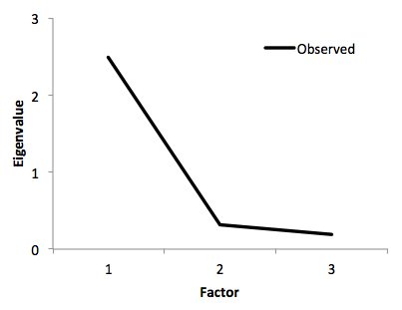

Figure 2. Retributive Justice Orientation scree plots of Eigenvalues by observed number of factors. All three subscales were subjected to Principal Axis Factoring.

Confirmatory Factor Analysis

We also used confirmatory factor analysis (CFA) to show that the three subscales could be subsumed under a single latent construct. We used Mplus 6.1 (Muthén & Muthén, 2010) to examine the Retributive Justice Orientation Scale’s (RJOS) factor structure using an confirmatory factor analysis (CFA), specifying a hierarchical model (e.g., Webster et al., 2014) in which items or item parcels (Little, Cunningham, Shahar, & Widaman, 2002) loaded on their respective subscale factors, and in which the subscale factors loaded on a single second-order RJO factor. Model fit was good, suggesting that all three subscales loaded onto the same second-order RJO factor (Fig. 3), χ2(24) = 129.97, *p* < .001, RMSEA = .096 [.081, .113], *p* < .001, CFI = .96, TLI = .94, SRMR = .030. RMSEA fit was marginal, whereas CFI, TLI, and SRMR indicated acceptable fit according to typical standards (Browne & Cudeck, 1993; Hu & Bentler, 1999).

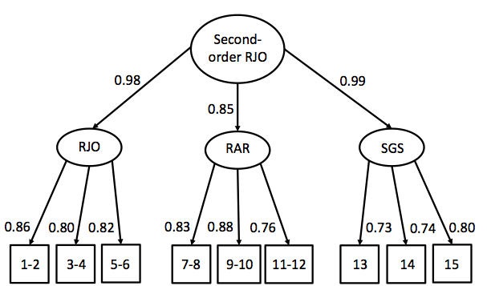

Fig. 3. Confirmatory factor analysis (CFA) results for the hierarchical models. All residual error terms were left uncorrelated. Standardized coefficients are shown. All coefficients were significant at *p* < .001. RJO = Retributive Justice Orientation scale (Okimoto, Wenzel, & Feather, 2012), RAR = Retribution as Revenge scale (Gerber & Jackson, 2013), SGS = Sentencing Goals Scale (Strelan, Feather, & McKee, 2011).

References

Browne, M. W., & Cudeck, R. (1993). Alternative ways of assessing model fit. *Sage Focus*

*Editions*, *154*, 136-136.

Gerber, M. M., & Jackson, J. (2013). Retribution as revenge and retribution as just deserts.

*Social Justice Research*, *26*(1), 61-80.

Horn, J. L. (1965). A rationale and test for the number of factors in Factor Analysis.

*Psychometrika*, 32, June, 179-185.

Hu, L. T., & Bentler, P. M. (1999). Cutoff criteria for fit indexes in covariance structure analysis:

Conventional criteria versus new alternatives. *Structural Equation Modeling: a*

*Multidisciplinary Journal*, *6*(1), 1-55.

Jackson, D. A. (1993). Stopping rules in principal component analysis: A comparison of

heuristical and statistical approaches. Ecology, 74, 2204–2214.

Little, T. D., Cunningham, W. A., Shahar, G., & Widaman, K. F. (2002). To parcel or not to

parcel: Exploring the question, weighing the merits. *Structural Equation Modeling*, *9*(2),

151-173.

Muthén, L. K., & Muthén, B. O. (2007). Mplus. *Statistical analysis with latent variables.*

*Version*, *3*.

Nichols, A. L., & Webster, G. D. (2015). Designing a brief measure of social anxiety:

Psychometric support for a three-item version of the Interaction Anxiousness Scale (IAS-

3). *Personality and Individual Differences*, *79*, 110-115.

O'Connor (2000) SPSS and SAS programs for determining the number of components using

parallel analysis and Velicer's MAP Test. *Behavior Research Methods, Instruments, &*

*Computers*, 32 (3), 396-402.

Okimoto, T. G., Wenzel, M., & Feather, N. T. (2012). Retribution and restoration as general

orientations towards justice. *European Journal of Personality*, *26*(3), 255-275.

Strelan, P., Feather, N. T., & McKee, I. (2011). Retributive and inclusive justice goals and

forgiveness: The influence of motivational values. *Social Justice Research*, *24*(2), 126-

142.

Webster, G. D., DeWall, C. N., Pond, R. S., Deckman, T., Jonason, P. K., Le, B. M., ... & Smith,

C. V. (2014). The brief aggression questionnaire: Psychometric and behavioral evidence

for an efficient measure of trait aggression. *Aggressive Behavior*, *40*(2), 120-139.